MPI Program
Kyle Angelo Alelis, Rey D. Balangue II, Sherwin Dan P. Morelos, Mapua University

Keywords—MPI – Message Passing Interface (key words)

Introduction

Parallel computing is now a part of everyone’s life as personal computers, smart phones, and other technologies are using this. It is a type of computation in which many calculations or the execution of processes are carried out simultaneously. Large problems can be often divided into smaller ones, which can be solved at the same time. MPI or Message Passing Interface uses this Parallel computing to apply it to programs. MPI is a standardized and portable message-passing to function on a wide variety of parallel computing architectures. The standard defines the syntax and semantics of a core of library routines useful to a wide range of users writing portable message programs in C, C++, and Fortran.

Problem Statement
By considering the MPI program, can MPI program prove that parallel-computing is faster than the usual one processor usage. By running a program with multiple processors and comparing it to a single processor.

Objectives
- To create a program using C++ without MPI to compare it with the MPI
- To use MPI programming in C++ to create a program
- To create the program that can input large number of files to have better performance in the processors.

Limitations of the Study
The study is coded in C++ including MPI programs and its pre-defined functions, and it will only be applicable to C++. The Algorithm that was used was ____ sorting algorithm, to sort the large input of data and process the data through the use of the Regular program, and the MPI coded program to compare the speed of process.

REVIEW OF RELATED LITERATURE

- Message Passing Interface (MPI)

The Message Passing Interface (MPI) is a standardized and portable message-passing standard designed by group of researchers on a wide variety of parallel computing architectures. MPI is also a communication protocol for programming for programming parallel computers.MPI’s goals are high performance, scalability, and portability.

III. Flowcharts

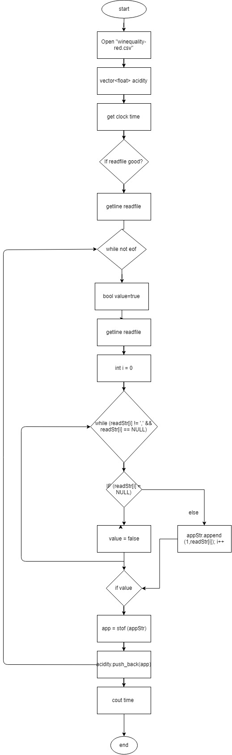
EnumSortSerial-main
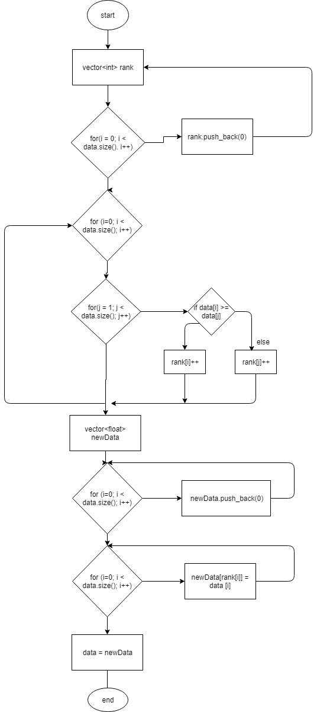
EnumSortSerial-void

Parallel Prcoessing flowchart

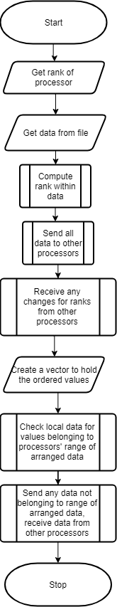

Functions:

MPI_Init – Initializes the MPI environment
MPI_Comm_rank – Determines the rank of the calling process in the communicator
MPI_Comm_size – Determines the size of the group associated with a communicator
MPI_send – Performs a blocking send, may block until the message is received by the destination process.
MPI_recv – Blocking receive for a message, the count argument indicates the maximum length of a message, which can be determined with MPI_Get_count
MPI_Barrier – Blocks until all processes in the communicator have reached the specific routine, blocks the caller until all process have called it. In short, it waits for all of the messages before it goes through.

Implementation

PARALLEL OUTPUT:
- Parallel Output 1:

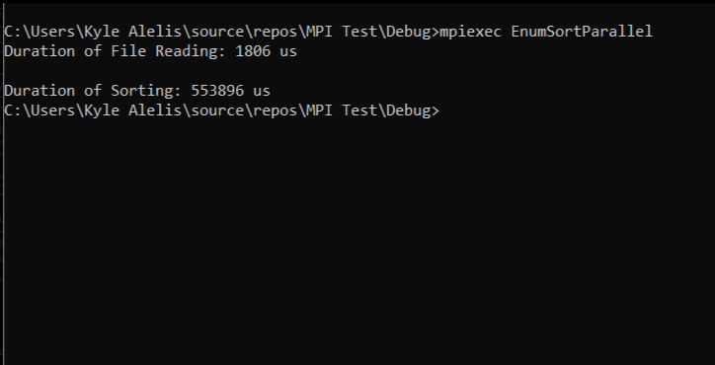
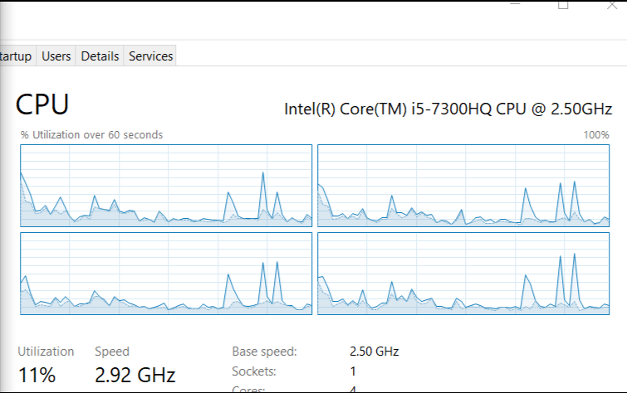

- Parallel Output 2:

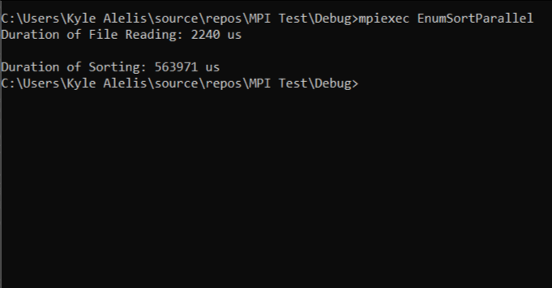
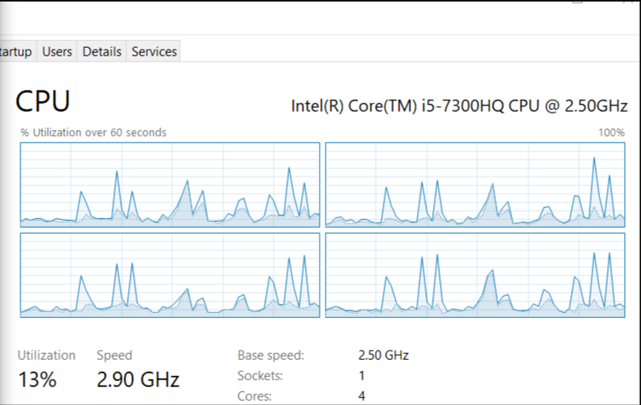

- Parallel Output 3:

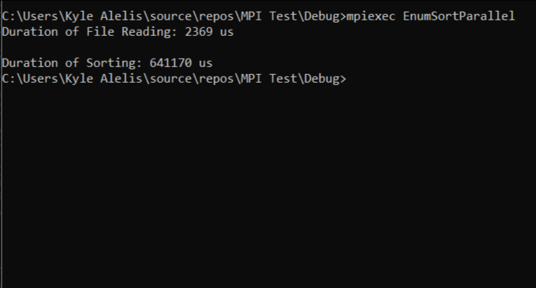
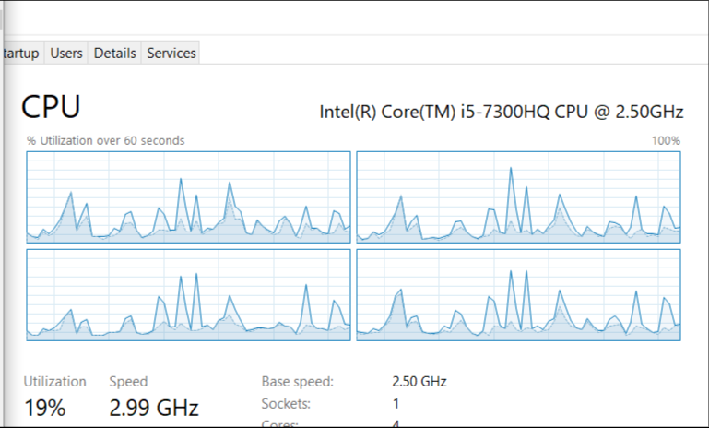

- Parallel Output 4:

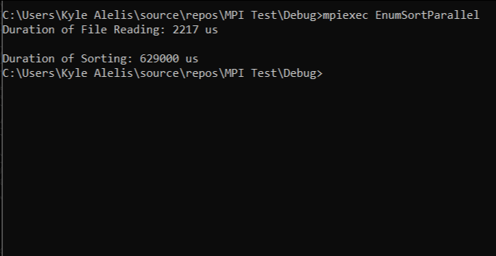
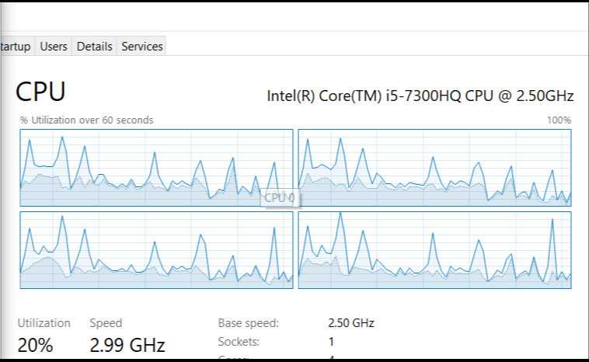

- Parallel Output 5:

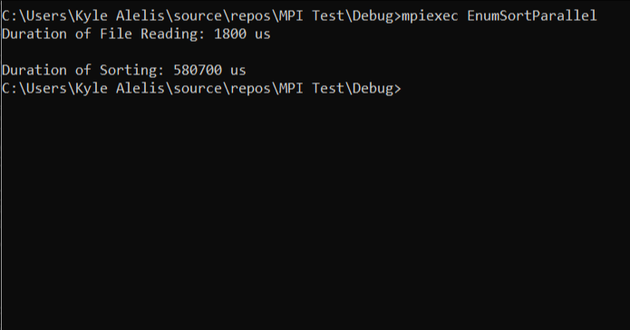
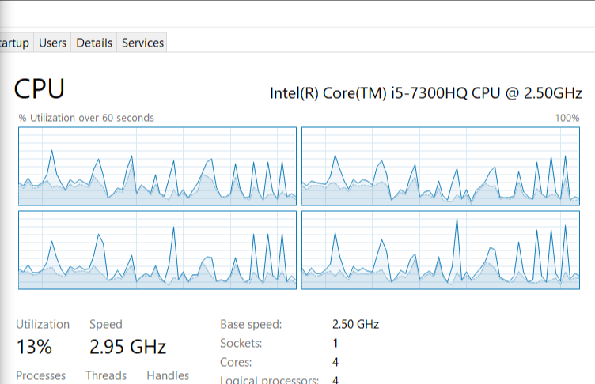

SERIES:

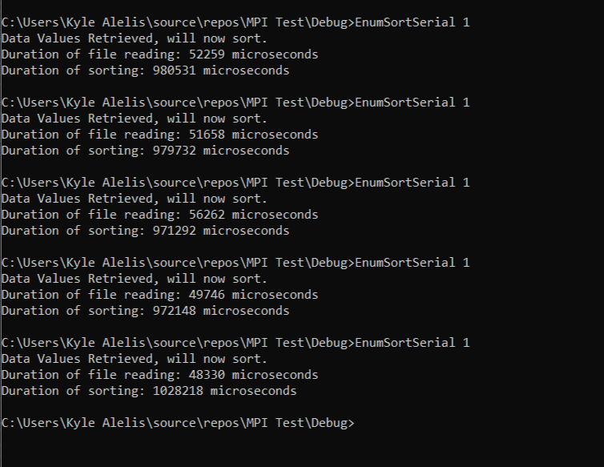
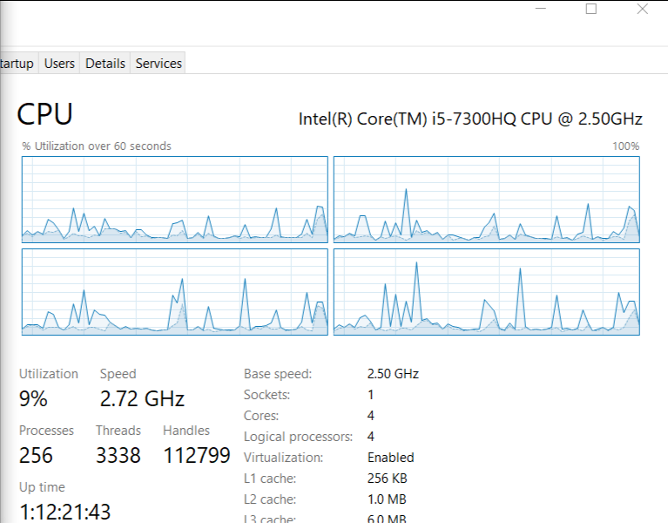

- ANALYSIS

Trial | Duration of Sorting: Series | Duration of Sorting: Parallel
1 | 980531 µs | 553896 µs
2 | 979732 µs | 563971 µs
3 | 971292 µs | 641170 µs
4 | 972148 µs | 629000 µs
5 | 1028218 µs | 580700 µs

